Summary of ITECH-3101

week 1 _ Lab Exercise

Created by: Boris Wijaya (30393908)

Exercise of Project 1

The first step of this lab required me to create my SAS profile to access the SAS studio, which I will use to test this Lab exercise project.

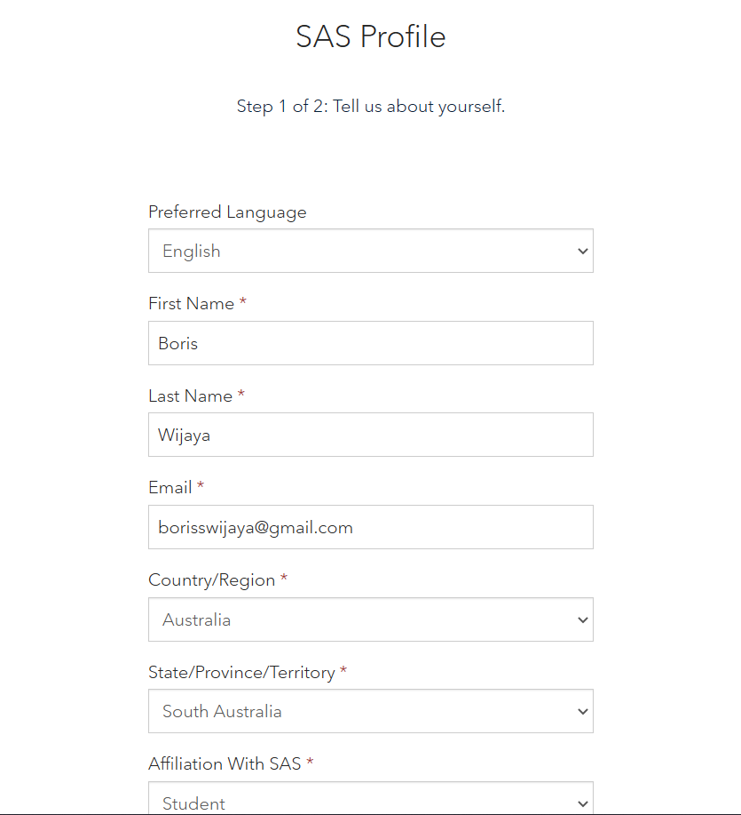

After creating my personal profile, I’m able to access the SAS dashboard.

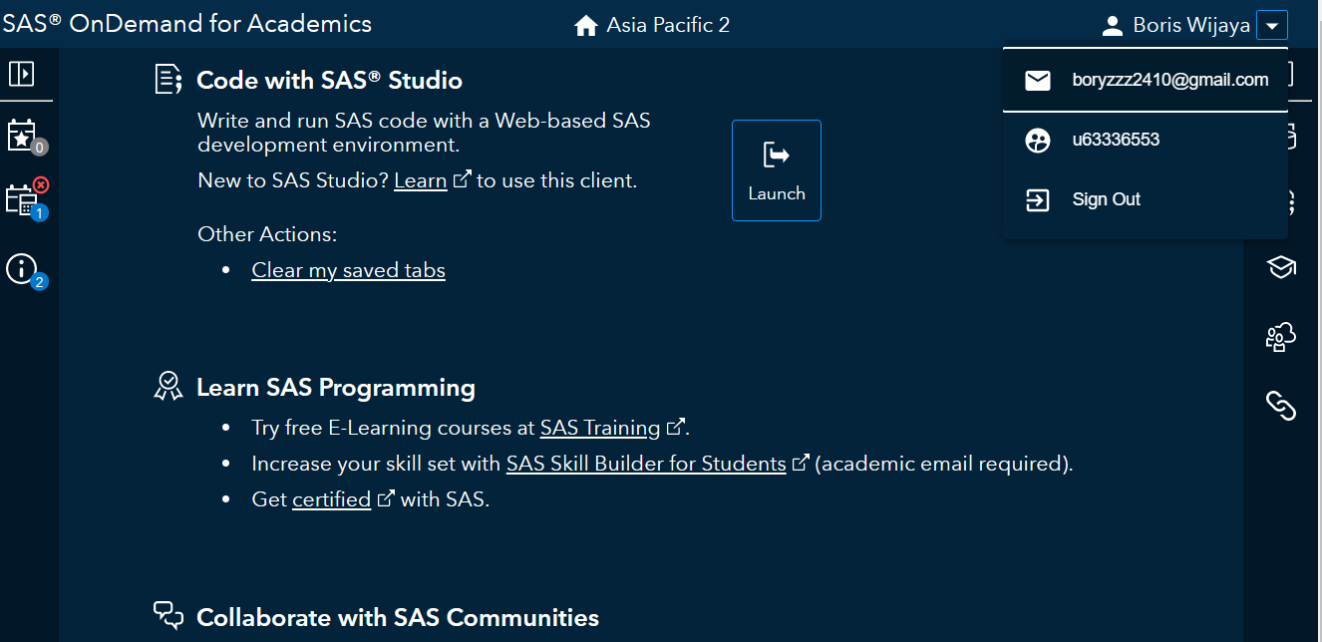

Next, I launch open the SAS studio from the dashboard menu, which allows me to view the SAS studio and test run my first SAS program.

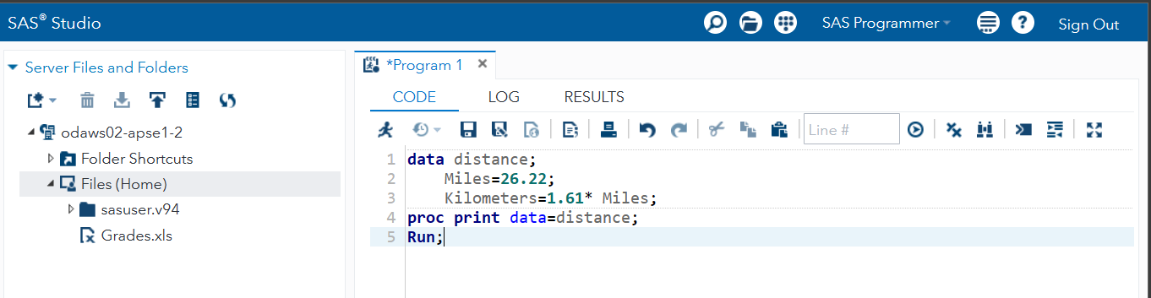

After running the above code it will shows result like this

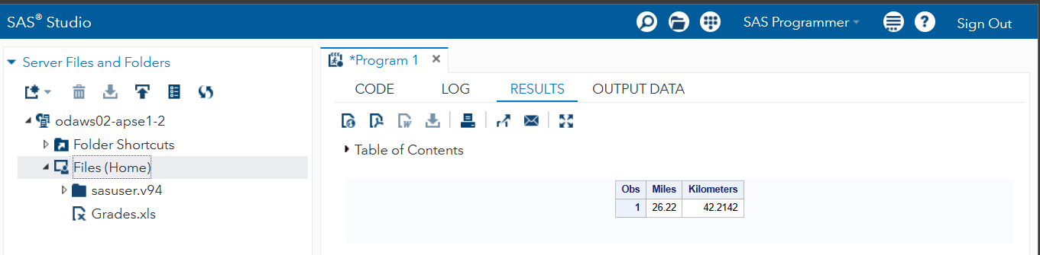

Exercise of Project 2

In this project, I learn the interfaces in SAS Studio using a built-in data set, which can be accessed from the “MyLibraries” file.

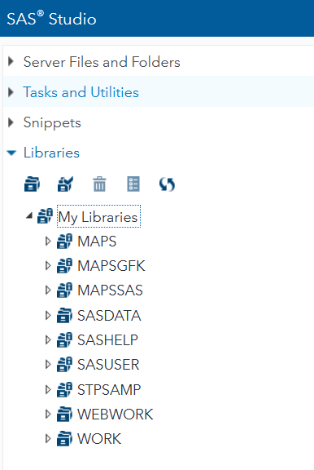

Then I open the file label “SASHELP” to access the “BASEBALL” data set which as a result show below.

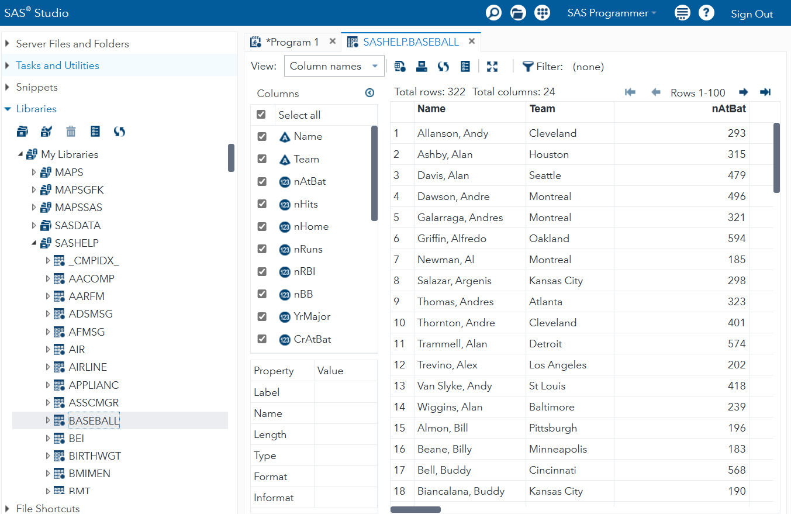

Next step I learn to add a filter on the column names, for example using the filter on “nHome” column with specific criteria to show data with the number of home runs that was 30 or more.

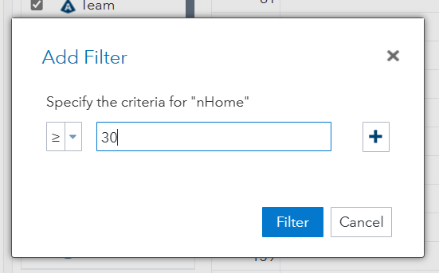

After adding the filter the table then shows data that all have 30 or more home run numbers as the result.

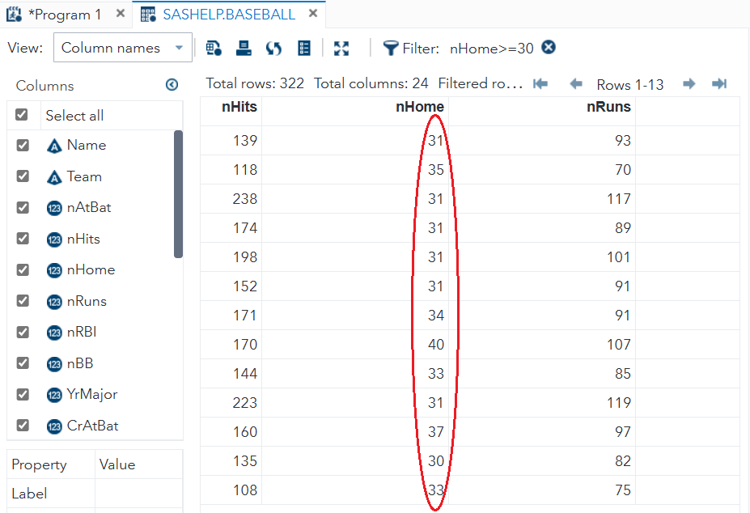

Exercise of Project 3

Testing other build-in data such as the data sets of “TOURISM” provided in SAS libraries.

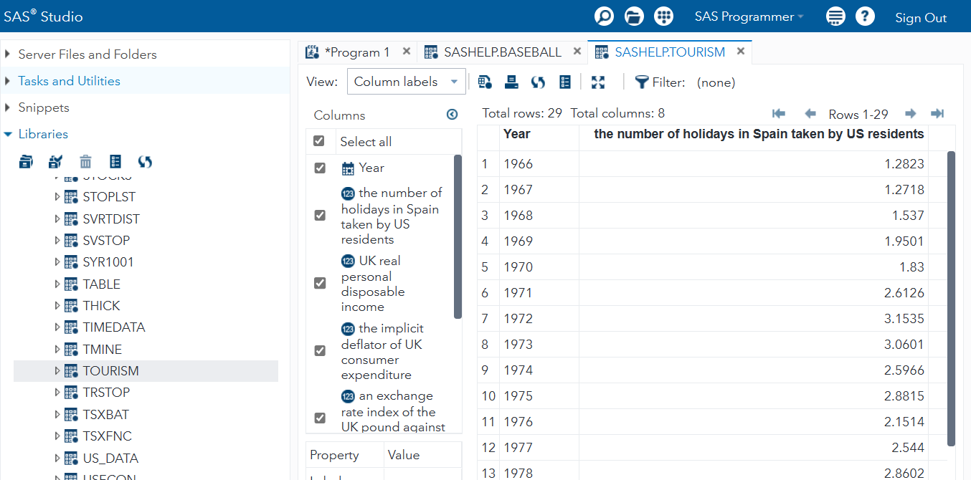

Adding a filter to the “year” column names wthe ith criteria shown below.

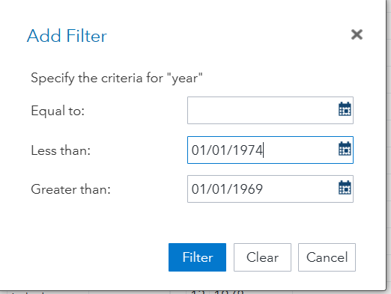

Result of the adding filter on “TOURISM” data table.

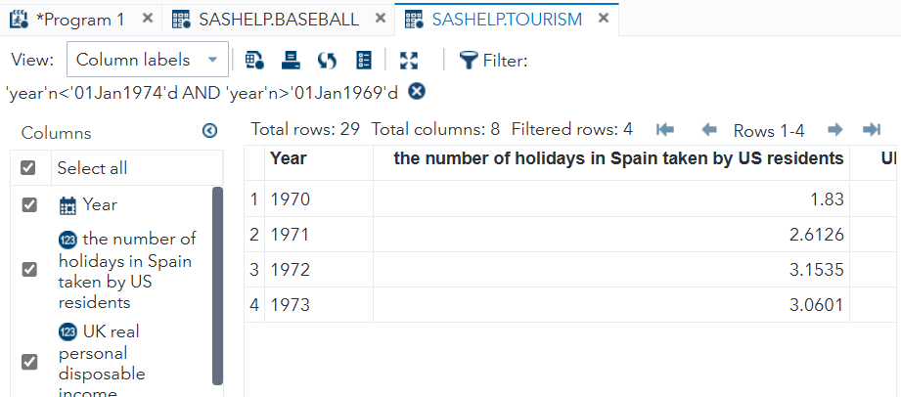

Answering Questions of Week-1 Lab

1. Managers usually make decisions by following a four-step process. What are the steps?

* Step 1 - Identify the concern of the problem
* Step 2 – Analyse the main factor caused by the problem
* Step 3 – Immediately implement the solution to counter it
* Step 4 – Evaluate the result and learn from the feedback